emerald_logo

**Emerald Group Publishing Limited**

SQL Server New Instance Install

(Configuration/Standards)

Document Version 1.0

|  |  |
| --- | --- |
| **Author** | N Gelder |
| **Creation Date** | 19th June 2013 |
| **Modified Date** |  |

**Table of Contents**

|  |
| --- |
| **1** – Purpose of Document |
| **2** – Document History |
| **6** – New SQL Server instance install configuration |

1. **Purpose of Document**

|  |
| --- |
| This document details the standard install configuration for all SQL Server instances which are installed on Emerald Group Publishing’s SQL Server estate. As Emerald doesn’t have a need to install new SQL Server instances on a regular basic an automated solution for new installations is not required.  This document only details the configuration side, it doesn’t hand hold someone through an installation of SQL Server and the expectation is the user of this document has knowledge of how to carry out an install of a SQL Server instance. |

1. **Document History**

|  |  |  |  |
| --- | --- | --- | --- |
| Version Number | Revision date | Summary of Changes | Issued Date |
| 1.0 | 19/06/2015 | First draft | 19/06/2015 |

1. **New SQL Server instance install configuration**

**PRE-INSTALL CHECKS**

These checks are to be carried out mainly on the new windows server which has been created as a host for the new SQL Server instance.

1. Check Windows update service is started and a connection to internet is available on the new windows server. The windows update service is used to check for new service packs during the install process and is only required until the installation is completed at which time this service can be re-disabled.
2. Check firewall is active or inactive (insert rules if needed for ports 1433 (service) & 1434 (Agent))
3. Check domain accounts have been created for the database service and SQL Agents, these should follow the following naming format [SQLInstanceName]\_SQLSRV (SQL Server Engine Service) & [SQLInstanceName]\_SQLSRV (SQL Agent Service) for example for a host DBL01 the following two account would need creating DBL01\_SQLSRV & DBL01\_SQLAG.
4. Create directory structure for data, log and tempdb data files, these are set to a standard of

D:\MSSQ\DATA – Database files

E:\MSSQL\LOG – Transaction log files

F:\MSSQL\DATA (TempDB)

The batch file in the SQL scripts folder *Create Data-Log-FTIndex file directory structure* will create these automatically if executed on the new windows host

1. Enable Instant file initialization – This zeros out non used data space, increases the speed of file expansion and creation of new databases, also speeds up restores. On the windows host go into Local Security Settings (click Start, Run, type SECPOL.MSC and hit enter) and click Local Policies, User Rights Assignment. In the permission “Perform Volume Maintenance Tasks”, add the SQL Server service account (or a domain group if you use that).
2. Set Processor scheduling - Click start - right click on computer - select properties - click advanced system settings.

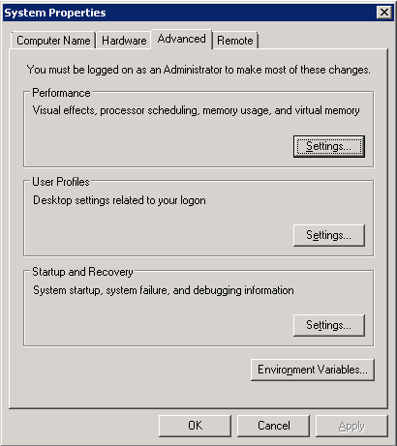

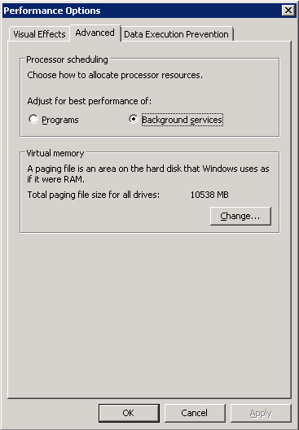

***DURING INSTALL***

1. ONLY Select components which are required, any additional components can be added if required at a later data.
2. Check Accounts are altered to new domain accounts for SQL Server Service and SQL Agent
3. Check Collation is Latin1\_General\_CI\_AS
4. Ensure TempDB and data files and logs are repointed to relevant directory setup

***POST INSTALL CHECK & CONFIGURATIONS***

*Execute setup scripts located in the same folder as this document*

1. *SQL Script - 1 - Move tempdb* – This SQL script will move the tempdb from its current default location on the system drive to its new location on the *F:\MSSQL\DATA* this should have been carried out as per step 12 during the installation, if so then only part of this script need to be executed to add the additional data files.
2. *SQL Script - 2 - Config and Options settings* – This SQL Script will set relevant settings from their defaults these configurations are as follows:

*Server configurations*

• MAXDOP = Number of CPUS on system

• Cost of parallelism = 35

• Max memory = Total memory available on host – 2GB

• optimize for ad hoc workloads

• backup compression default

• Ole Automation Procedures

• remote admin connection

• Ad Hoc Distributed Queries

• contained database authentication

• Agent XPs

All system databases MASTER, MSDB and MODEL need the following setting applied

* Auto growth set to 100MB and percentage growth disabled
* Recovery model set to Simple
* Initial data file size altered to 150MB and Log file 50MB (this is for the model database only)

*TraceFlags*

The following Trace flags require turning on and adding to startup flags through SSCM

* 3326
* 1117
* 1118
* 1204
* 1222

1. *SQL Script 3 - Create Admin\_DBA - DB - SP's – Views –* This script creates the Admin\_DBA database which is used to store any views tables, stored procedures etc required for daily reporting, baseline etc
2. *SQL Script 4 - Setup SQLAgent - Alerts - Mail – Operators* – This script is used to configure the database mail, operators and alerts required i.e. severity alerts for 18+, data file full, log file full.
3. *SQL Script 5 - Create SQL Agent DR Jobs & Schedule creation –* This creates the backup, and index maintenance solution ([ola hallengren](https://ola.hallengren.com/)).
4. *6 - Create Maintenance SQL Agent Jobs & Schedule* – This Script creates the relevant other daily and weekly maintenance SQL agent jobs with schedules.
5. Alter logins for SQL Service and agent services to Domain accounts, remember to stop the service before carrying out this otherwise SSPI problems will occur (THIS MUST BE CARRIED OUT IN SQL SERVER CONFIGURATION MANAGER NOT WINDOWS SERVICES). This is only required if not completed in step 10
6. Add SQL Server service accounts domain logins in SSMS, SQL Server agent should be sys admin, but the service login can just have connect rights.
7. Check SQL browser service is disabled as this is only needed for named instances, however alter login to same as SQL database engine service in-case this is needed in the future.
8. Check SQL Agent service is set to automatic.
9. Check TCP/IP Protocol is enabled
10. Alter error log recycle amount to 14
11. Alter data and log file location & backup Location is SSMS
12. Import Policy based management best practice templates.
13. Install SP\_Whoisactive into master database (see script Who\_is\_active.sql file)
14. Ensure Operators are setup to receive emails when jobs fail

USE msdb

SELECT \*

FROM sysjobs

WHERE notify\_email\_operator\_id = 0

1. Check SQL Agent Fail safe operator is selected
2. Run Sp\_Blitz (from app installed on PC or install proc from http://www.brentozar.com/blitz) and correct any problem with results.